**Smart Contract**

Code in Remix IDE using Solidity

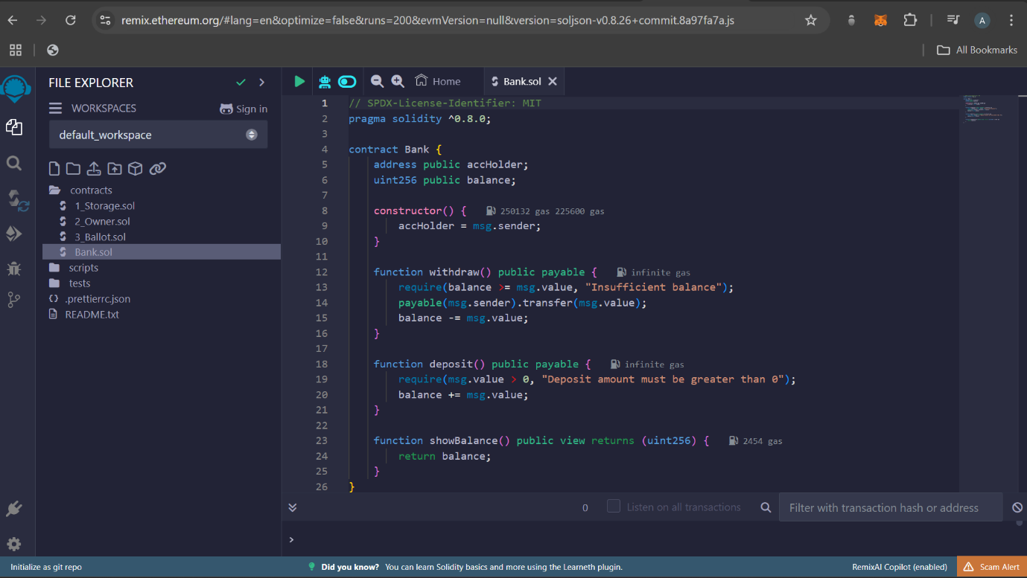

Click on compile (3rd symbol). Click on “Auto Compile”, if compilation is successful, it will show green tick

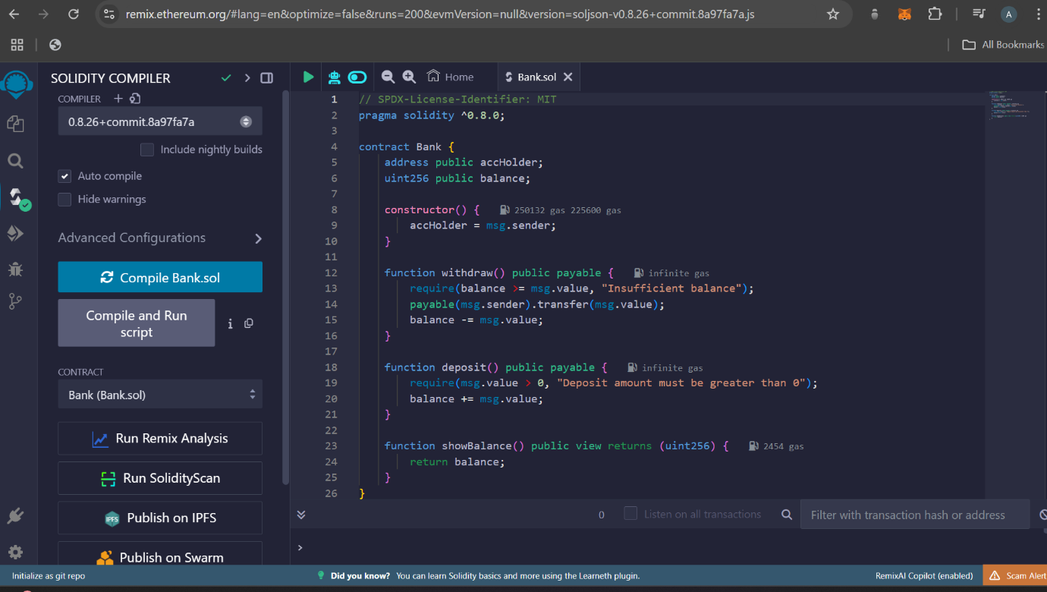

Click on deploy symbol (4th symbol) and then “deploy” button

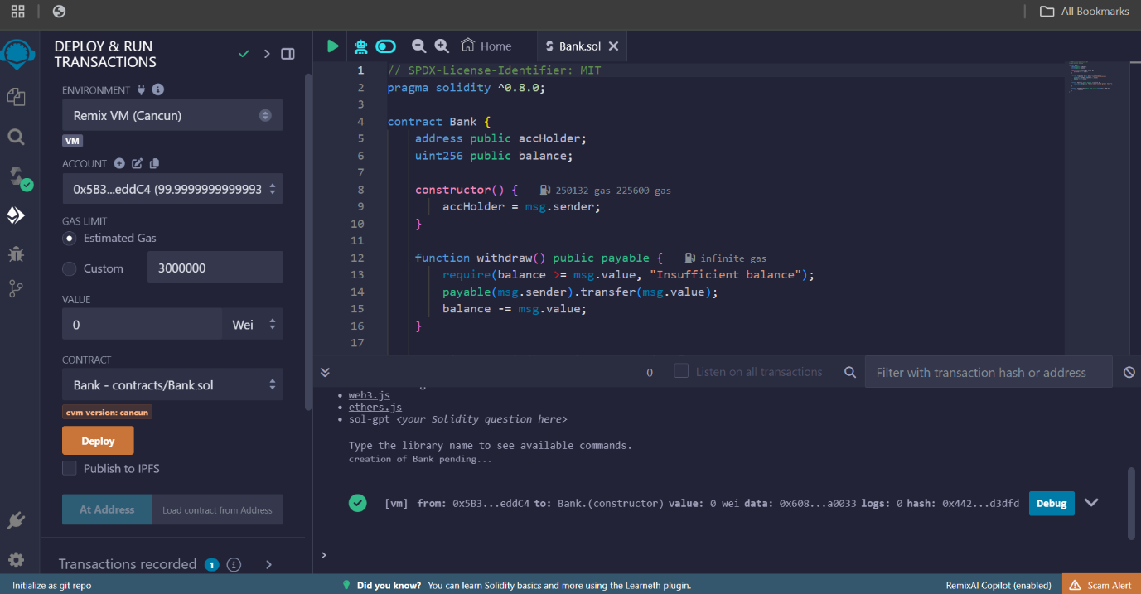

Scroll down and you can see functions, you can use it

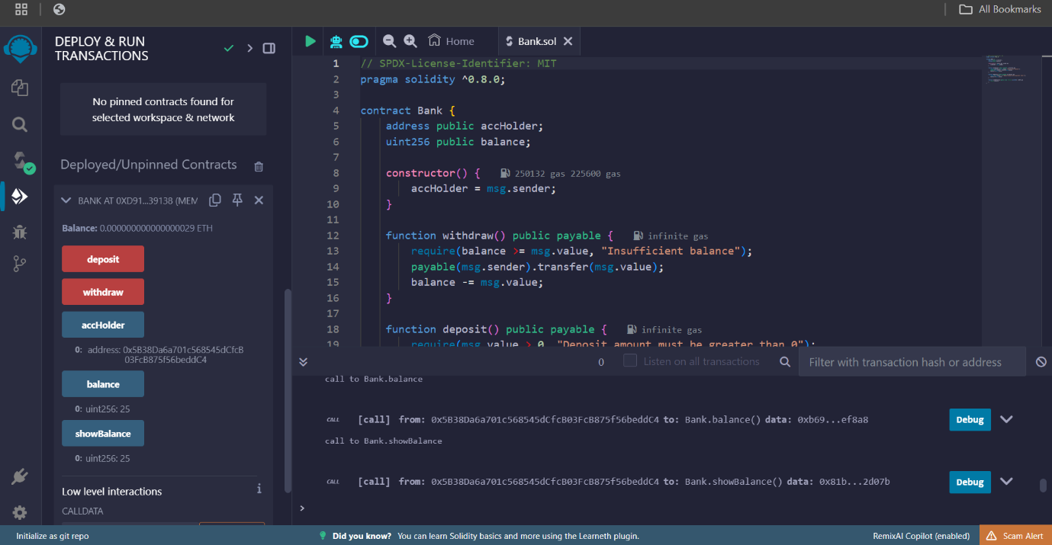

// SPDX-License-Identifier: MIT

pragma solidity >= 0.8.0;

contract Account{

uint myBalance;

address userAddress;

constructor(uint balance){

myBalance = balance;

userAddress = msg.sender;

}

function depositMoney(uint amount) external returns(string memory message){

require(amount > 0, "INVALID_DEPOSIT_AMOUNT_ERROR : Cannot deposit amount equal to, or less than 0 !");

myBalance += amount;

return("WITHDRAWAL TRANSACTION SUCCESSFUL !");

}

function withdrawMoney(uint amount) external returns(string memory message){

require(amount < myBalance, "LOW_BALANCE_ERROR : No sufficient funds in Account !");

myBalance -= amount;

return("DEPOSIT TRANSACTION SUCCESSFUL !");

}

function getBalance() external view returns(uint balance){

return(myBalance);

}

function getUserAddress() external view returns(address addr){

return(userAddress);

}

}